**List of Web maps**

1. **Serving communities across NC since 1988**

<https://www.nccommunityfoundation.org/communities>

I liked this map because of two major reasons:

* I was able to see details in most of counties that were hyperlinked.
* I liked the topic of it that was showing the donations in each community. I think these kind of information can encourage people to help others more.

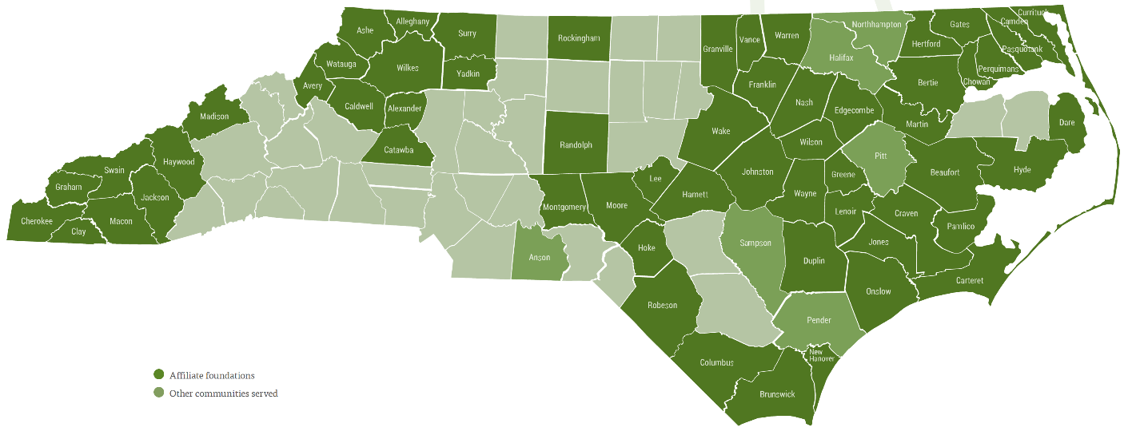

1. **Disadvantaged Communities (DACs) / Tribal Lands & U.S. Territories**

[**https://energyjustice.egs.anl.gov/**](https://energyjustice.egs.anl.gov/)

Since I was 3 years in Houston. I liked to check its data. Interestingly most of disadvantaged communities are in Dallas and Fort Worth. Dallas is a



